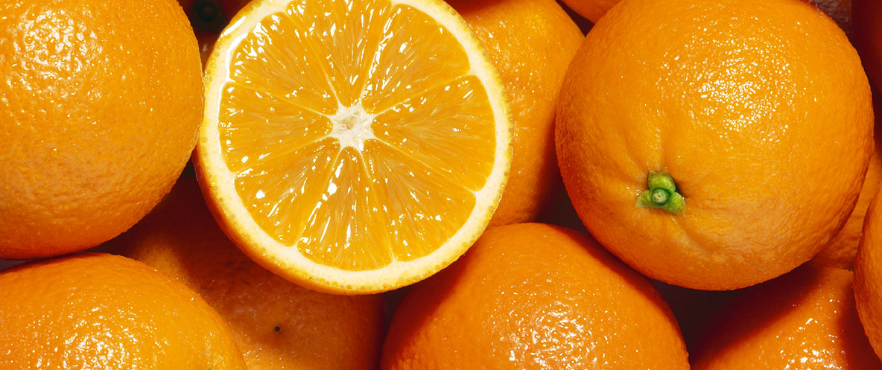

Orange Uses
Glass Cleaner
Combine 1 cup of white vinegar, 1 cup of distilled water, and 20 drops of Orange Essential Oil in a spray bottle for a natural glass cleaner. Shake before use.
Energizing Diffuser Blend
Try one of the combinations below in your diffuser:
- 3 drops Orange + 3 drops Peppermint
- 2 drops Orange + 2 drops Bergamot + 2 drops Lemon
- 1 drop Orange + 2 drops Lemon + 1 drop Lime + 1 drop Grapefruit
Sources: lorannoils.com and pinterest.com

