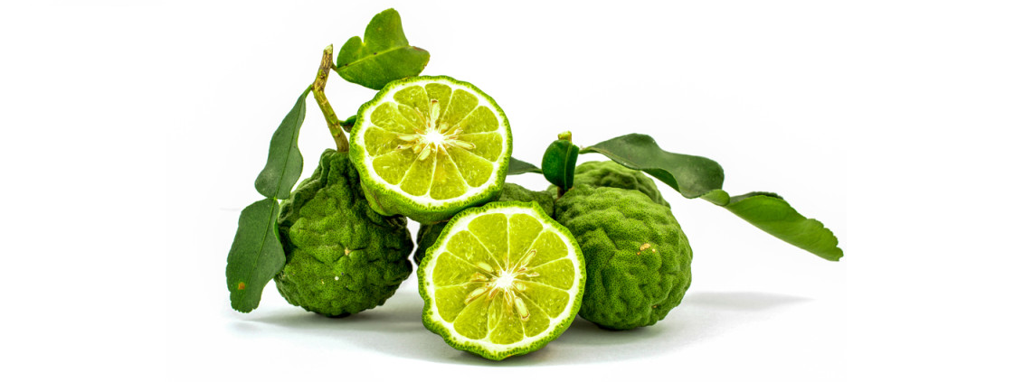

Bergamot Uses
Emotional/Stress Relief
In your diffuser: 3 drops Bergamot, 3 drops Frankincense, 3 drops Lemon
In your hands: apply 3 drops of Bergamot and cup towards nose/mouth*
- for this remedy, dilute and test a little of the oil on your hand to ensure no unknown skin sensitivity exists
*do not touch to eyes, wash hands after use
Exfoliating Body Polish
Mix:
- 5-6 drops of Bergamot
- 1 cup cane sugar
- 1 cup freeze-dried strawberries
- ¾ cup extra virgin coconut oil
- 1 tbsp. vanilla extract

Source: pinterest.com and doterra.com

