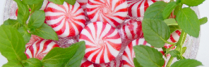

Peppermint Uses
Energizing Blend for diffuser, bath, or spray
Use:
- 10 drops of Orange Essential Oil
- 6 drops of Peppermint Essential Oil
For bath preparations: dilute mixture with 1-2 ounces of carrier oil like Sweet Almond Oil and add to bath
- *for this remedy, dilute and test a little of the oil on your hand to ensure no unknown skin sensitivity exists
*do not touch to eyes, wash hands after use
For room spray: dilute with water as desired and mist around room to add energizing fragrance.
Sources: lorannoils.com

