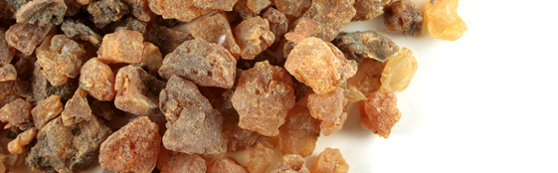

Myrrh Uses
Removal of Fine Lines
Adding a few drops of Myrrh Essential Oil to your lotion or moisturizer can reduce fine lines or wrinkles.
- *for this remedy, dilute and test a little of the oil on your hand to ensure no unknown skin sensitivity exists
*do not touch to eyes, wash hands after use
Myrrh and Frankincense Beauty Cream
Ingredients:
- ½ cup whipped coconut oil
- ¼ teaspoon Vitamin E oil
- 5 drops Frankincense Essential Oil
- 3 drops Myrrh Essential Oil
Whip coconut oil in had beater for 1-3 minutes. If the coconut oil is melted you will need to refrigerate it before making this cream. Add the oils and continue mixing. To use: apply a small amount to face as needed (*see above about potential sensitivity). Keep in a re-sealable container.
Sources: doterra.com and thecoconutmama.com

