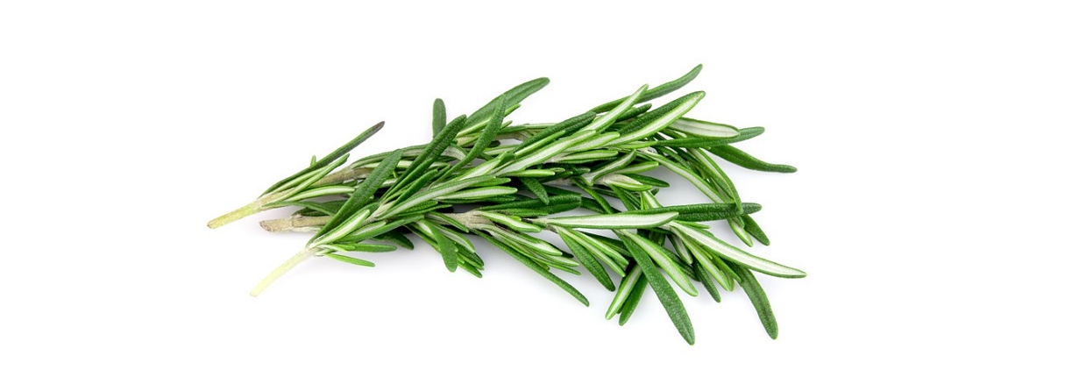

rosemary
For Diffuser Use
To keep concentration up during studying diffuse 3-4 drops around the room.
Rosemary and Lemon Body Scrub
Mix:
- 1 and ½ cups of Epsom salts
- 3 drops of Rosemary Essential Oil
- 2-3 drops of Lemon Essential Oil
- 3 tbsp melted coconut oil
- 2 tbsp lemon zest
Keep in an air tight container and it will keep for 1-2 months.
Sources: pinterest.com and doterra.com

