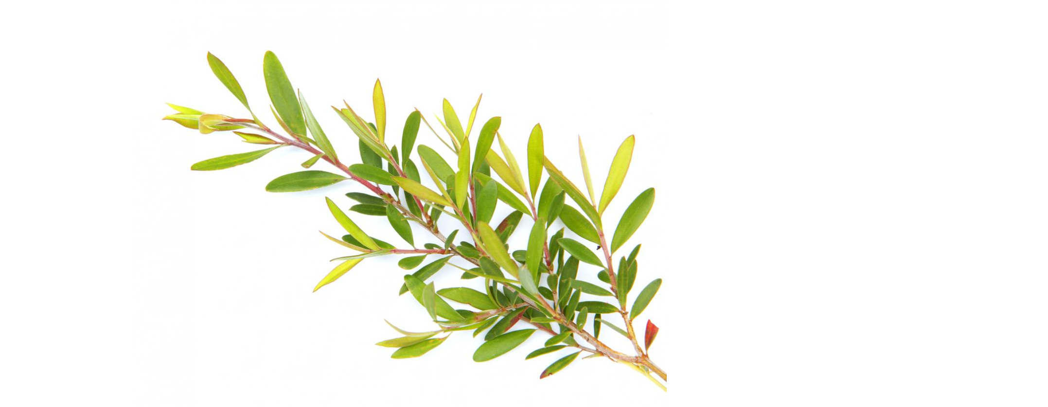

Tea Tree Uses
DIY soothing Lotion
Mix:
- 1 tbsp shea butter
- 5-7 drops of Tea Tree Essential Oil
- 5 drops of Lavender Essential Oil
Apply to clean skin daily, anywhere you might have blemishes or eczema.
- for this remedy, dilute and test a little of the oil on your hand to ensure no unknown skin sensitivity exists
*do not touch to eyes, wash hands after use
Source: pinterest.com

